Sorting and filtering
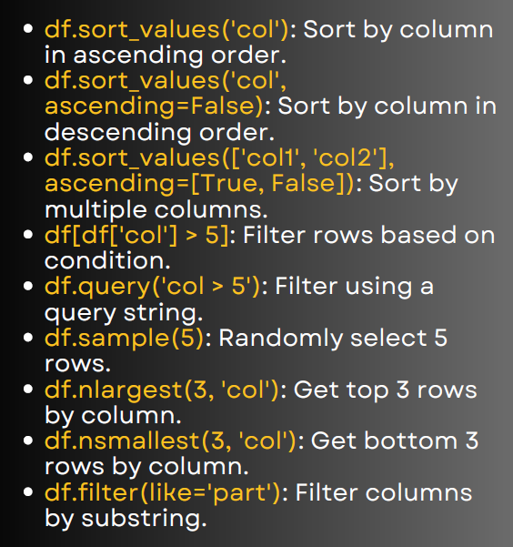

First, let’s create a sample dataset:

import pandas as pd
data = {
'Name': ['Alice', 'Bob', 'Charlie', 'David', 'Eva'],
'Age': [25, 30, 35, 40, 28],
'Salary': [50000, 60000, 70000, 80000, 55000],
'Dept': ['HR', 'IT', 'Finance', 'IT', 'HR']
}
df = pd.DataFrame(data)
print(df)

output :-
Name Age Salary Dept
0 Alice 25 50000 HR
1 Bob 30 60000 IT
2 Charlie 35 70000 Finance
3 David 40 80000 IT
4 Eva 28 55000 HR

Sorting
# 1. Sort by column (ascending by default)
df.sort_values('Age')
Output: Rows sorted by Age from youngest to oldest.

# 2. Sort by column in descending order
df.sort_values('Salary', ascending=False)
Output: Rows sorted by Salary from highest to lowest.

# 3. Sort by multiple columns (Age ascending, Salary descending)
df.sort_values(['Dept', 'Salary'], ascending=[True, False])
Output: First sort by Dept, then within each department sort Salary descending.

Filtering
# 4. Filter rows based on condition (Age > 30)
df[df['Age'] > 30]
Output: Only rows where Age > 30.

# 5. Filter using query string
df.query('Salary >= 60000')
Output: Employees with Salary ≥ 60000.

# 6. Randomly select 2 rows
df.sample(2)
Output: Random 2 rows from dataset (changes each run).

# 7. Get top 3 highest salaries
df.nlargest(3, 'Salary')
Output: Top 3 employees with highest salary.

# 8. Get bottom 3 lowest salaries
df.nsmallest(3, 'Salary')
Output: Bottom 3 employees with lowest salary.

# 9. Filter columns containing substring "a"
df.filter(like='a')
Output: Only columns whose names contain 'a' (e.g., Name, Salary).

